OSPF LSA Lab Report

Name: Jacob Chen

Date: 9/29/2023

Lab Partner: Aaron Yu Aiden Yin

Class: CCNP 2023-2024

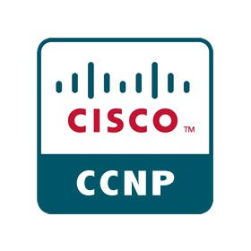

**Purpose**

OSPF is an open-source routing protocol that helps to route packets between different networks. In this lab we experimented with multi-area OSPF. The purpose of the lab is to learn about the various “flavors” of OSPF and their unique advantages. OSPF’s wide use within industry makes it a key protocol for any network engineer to study. Learning the strengths/weaknesses of the various types of OSPF is a key element in designing efficient network topologies.

**Background**

OSPF has a couple specific implementations that modify how OSPF runs and have their own unique advantages.

**Stub Areas** block type 5 LSAs, which are external OSPF routes. Instead routers in the stub network are given a default route to the ASBR in exchange for . This is very useful in branch networks, where the only connection is to the backbone area. Under normal OSPF implementations, all routers in the branch area would need to keep an accurate routing table of every other network, using memory and slowing down the forwarding process. To improve these, OSPF stub areas remove all external routes, routers in a stub area keep track of all other OSPF processes, and get a default route for external routes.

**Totally stub** areas continue with the simplicity of stub areas. Instead of keeping track of the entire OSPF process, inside a totally stub area, all external routes are placed with a default route to the ABR. This includes all other OSPF processes. This is the most efficient use of resources for OSPF networks, but also has the severe limitation of only working for edge networks. If an OSPF process has multiple ways to leave the networks, don’t use a totally stub area. In terms of LSA types, totally stub areas block type 3 LSAs in addition to blocking type 5 LSAs.

**Not So Stubby** areas are similar to stub areas but with one key difference. They forward external routes in the form of type 7 LSA packets. You would want to use this kind of OSPF implementation when you care about the size of the routing table for the network, but also want to make sure that the rest of the OSPF network is aware of any external routes. These OSPF networks take external routes in the form of type 7 LSAs and then turn them into type 5 LSAs as they transfer into the backbone network.

**Type 1 LSA – Router LSA**: They are the main type of OSPF LSAs and contain information about the router that it generates it including the router ID and its originating area. These form the core type of LSAs used to allow other devices on the OSPF network to get accurate knowledge of the network topology.

**Type 2 LSA – Network LSA**: These are generated by the DR and contain information like Ip addresses about each of the directly connected links to the designated router. This LSA type in conjunction with type 1 LSAs allow routers in an OSPF area to create and maintain and accurate representation of the area topology.

**Type 3 LSA – Summary LSA**: These are created by the ABR and flooded into connecting OSPF areas. They contain summarize information about other OSPF networks and propagate a default route that points to the ABR. This way devices in an OSPF stub area can maintain knowledge of other OSPF areas and have a way to get to those other areas.

**Type 4 LSA – Summary ASBR LSA**: Similar to a type 3 LSA, these are generated to help other routers find the ASBR. An ABR will generate a summary ASBR LSA which contains the router Id of the ASBR.

**Type 5 LSA – External LSA**: These LSA types are generated by the ABR and contain information about external networks. These are extremely useful, as they allow your OSPF network to talk to networks using different routing protocols.

**Type 7 LSA – External LSA**: These are another form of external LSA that is generated by a NSSA ASBR. The main purpose of these LSAs is to not violate the “no type 5” rule of stub areas while not losing any information. These LSA types are only found within an NSSA area and are converted to normal Type 5 LSAs by the ABR.

**Lab Summary**

First, we created a general topology for the entire setup including 4 different networks, corresponding IPv4 and IPv6 addresses, and the associated wiring.

After wiring up the diagram, on each of the routers we preformed the following rough steps.

1. Set up basic device configuration including hostname and general device security.
2. Turned on interfaces and set associated IPv4 on said interfaces.
3. Configured OSPFv2 as necessitated to set up OSPF based on the topology, and configured various OSPF areas as based on topology
4. Used Wireshark to scan for various LSA types

**Lab Commands**

**Hostname JacobAaronRX**: Sets a unique hostname to identify the various routers

**Interface g0/0/X**: Access the interfaces

**No shut**: Turns on the interfaces

**Ip add 192.168.x.x 255.255.255.0**: sets an ipv4 address on an interface

**Ip ospf 1 area x**: Sets an OSPF process id of 1 and an associated area on an interface

**Router ospf 1**: access ospfv2 configuration on the router

**Router-id x.x.x.x**: sets a specific router id for that router to use for OSPF

**area x stub**: specifies that the OSPF area is a stub area

**area x stub no-summary**: Specifies that a specific OSPF area is a totally stubby area

**area x nssa**: specifies that the OSPF area is a not so stubby area

**Router Configurations**

**R1 Config**

version 16.6.4

no service timestamps log datetime msec

no service timestamps debug datetime msec

no service password-encryption

hostname JacobAaronAidenR1

ip cef

no ipv6 cef

spanning-tree mode pvst

interface GigabitEthernet0/0/0

ip address 10.0.0.1 255.255.255.0

ip ospf 1 area 0

duplex auto

speed auto

interface GigabitEthernet0/0/1

ip address 10.0.1.1 255.255.255.0

ip ospf 1 area 1

duplex auto

speed auto

interface GigabitEthernet0/0/2

no ip address

duplex auto

speed auto

shutdown

interface Vlan1

no ip address

shutdown

router ospf 1

router-id 1.1.1.1

log-adjacency-changes

area 1 stub

ip classless

ip flow-export version 9

line con 0

line aux 0

line vty 0 4

login

end

**R2 Config**

version 16.6.4

no service timestamps log datetime msec

no service timestamps debug datetime msec

no service password-encryption

hostname JacobAaronAidenR2

ip cef

no ipv6 cef

spanning-tree mode pvst

interface GigabitEthernet0/0/0

no ip address

duplex auto

speed auto

shutdown

interface GigabitEthernet0/0/1

ip address 10.0.1.2 255.255.255.0

ip ospf 1 area 1

duplex auto

speed auto

interface GigabitEthernet0/0/2

no ip address

duplex auto

speed auto

shutdown

interface Vlan1

no ip address

shutdown

router ospf 1

router-id 2.2.2.2

log-adjacency-changes

area 1 stub

ip classless

ip flow-export version 9

line con 0

line aux 0

line vty 0 4

login

end

**R3 Config**

version 16.6.4

no service timestamps log datetime msec

no service timestamps debug datetime msec

no service password-encryption

hostname JacobAaronAidenR3

no ip cef

no ipv6 cef

spanning-tree mode pvst

interface GigabitEthernet0/0/0

ip address 10.0.0.2 255.255.255.0

ip ospf 1 area 0

duplex auto

speed auto

interface GigabitEthernet0/0/1

ip address 10.0.2.1 255.255.255.0

ip ospf 1 area 2

duplex auto

speed auto

interface GigabitEthernet0/0/2

no ip address

duplex auto

speed auto

shutdown

interface Vlan1

no ip address

shutdown

router ospf 1

router-id 3.3.3.3

log-adjacency-changes

area 2 stub no-summary

ip classless

ip flow-export version 9

line con 0

line aux 0

line vty 0 4

login

end

**R4 Config**

version 16.6.4

no service timestamps log datetime msec

no service timestamps debug datetime msec

no service password-encryption

hostname JacobAaronAidenR4

no ip cef

no ipv6 cef

spanning-tree mode pvst

interface GigabitEthernet0/0/0

no ip address

duplex auto

speed auto

shutdown

interface GigabitEthernet0/0/1

ip address 10.0.2.2 255.255.255.0

ip ospf 1 area 2

duplex auto

speed auto

interface GigabitEthernet0/0/2

no ip address

duplex auto

speed auto

shutdown

interface Vlan1

no ip address

shutdown

router ospf 1

router-id 4.4.4.4

log-adjacency-changes

area 2 stub no-summary

ip classless

ip flow-export version 9

line con 0

line aux 0

line vty 0 4

login

end

**R5 Config**

version 16.6.4

no service timestamps log datetime msec

no service timestamps debug datetime msec

no service password-encryption

hostname JacobAaronAidenR5

no ip cef

no ipv6 cef

spanning-tree mode pvst

interface GigabitEthernet0/0/0

ip address 10.0.0.3 255.255.255.0

ip ospf 1 area 0

duplex auto

speed auto

interface GigabitEthernet0/0/1

ip address 10.0.3.1 255.255.255.0

ip ospf 1 area 3

duplex auto

speed auto

interface GigabitEthernet0/0/2

no ip address

duplex auto

speed auto

shutdown

interface Vlan1

no ip address

shutdown

router ospf 1

router-id 5.5.5.5

log-adjacency-changes

area 3 nssa

ip classless

ip flow-export version 9

line con 0

line aux 0

line vty 0 4

login

end

**R6 Config**

version 16.6.4

no service timestamps log datetime msec

no service timestamps debug datetime msec

no service password-encryption

hostname JacobAaronAidenR6

no ip cef

no ipv6 cef

spanning-tree mode pvst

interface Loopback0

ip address 23.23.23.23 255.0.0.0

interface GigabitEthernet0/0/0

no ip address

duplex auto

speed auto

shutdown

interface GigabitEthernet0/0/1

ip address 10.0.3.2 255.255.255.0

ip ospf 1 area 3

duplex auto

speed auto

interface GigabitEthernet0/0/2

no ip address

duplex auto

speed auto

shutdown

interface Vlan1

no ip address

shutdown

router ospf 1

router-id 6.6.6.6

log-adjacency-changes

ip classless

ip route 0.0.0.0 0.0.0.0 Loopback0

ip flow-export version 9

line con 0

line aux 0

line vty 0 4

login

end

**R7 Config**

version 16.6.4

no service timestamps log datetime msec

no service timestamps debug datetime msec

no service password-encryption

hostname JacobAaronAidenR7

no ip cef

no ipv6 cef

spanning-tree mode pvst

interface GigabitEthernet0/0/0

ip address 10.0.0.4 255.255.255.0

ip ospf 1 area 0

duplex auto

speed auto

interface GigabitEthernet0/0/1

ip address 10.0.4.1 255.255.255.0

ip ospf 1 area 4

duplex auto

speed auto

interface GigabitEthernet0/0/2

no ip address

duplex auto

speed auto

shutdown

interface Vlan1

no ip address

shutdown

router ospf 1

router-id 7.7.7.7

log-adjacency-changes

ip classless

ip flow-export version 9

line con 0

line aux 0

line vty 0 4

login

end

**R8 Config**

version 16.6.4

no service timestamps log datetime msec

no service timestamps debug datetime msec

no service password-encryption

hostname JacobAaronAidenR8

no ip cef

no ipv6 cef

spanning-tree mode pvst

interface Loopback0

ip address 34.34.34.34 255.0.0.0

interface GigabitEthernet0/0/0

no ip address

duplex auto

speed auto

shutdown

interface GigabitEthernet0/0/1

ip address 10.0.4.2 255.255.255.0

ip ospf 1 area 4

duplex auto

speed auto

interface GigabitEthernet0/0/2

no ip address

duplex auto

speed auto

shutdown

interface Vlan1

no ip address

shutdown

router ospf 1

router-id 8.8.8.8

log-adjacency-changes

default-information originate

ip classless

ip route 0.0.0.0 0.0.0.0 Loopback0

ip flow-export version 9

line con 0

line aux 0

line vty 0 4

login

end

**Topology**

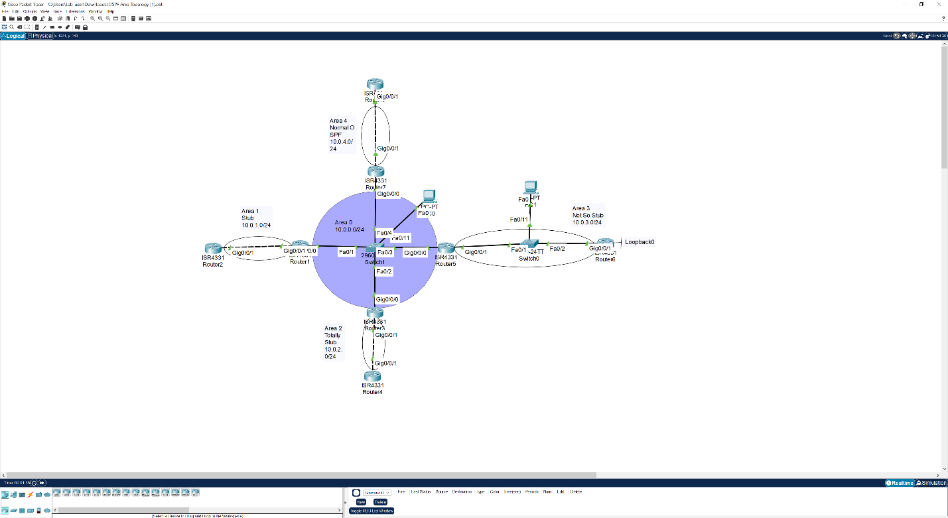

**Proof of LSA Types/Signoff**

LSA type 1,2,3,7

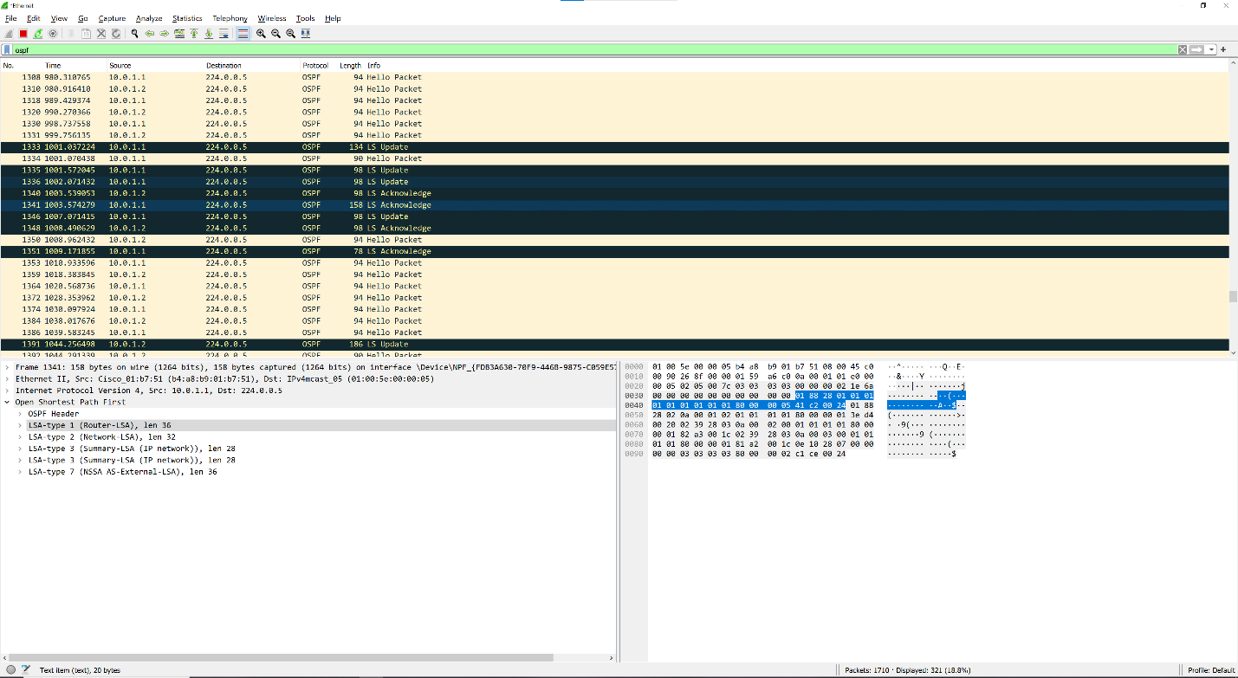

LSA type 4,5

